CSA1717-ARTIFICIAL INTELLIGENCE
PRACTICAL LAB EXPERIMENTS
NIHARIKA PREEJESH (192524506)

PROGRAM 15: A* ALGORITHM
Aim: To implement the A* algorithm to find the shortest path between the source node and the goal node using path cost and heuristic values.
Algorithm
- Define the graph with edge costs and heuristic values.
- Insert the source node into the priority queue.
- Calculate f(n) = g(n) + h(n) for each node.
- Expand the node with the smallest f(n) value.
- Update the path cost for neighboring nodes.
- Repeat until the goal node is reached.
- Display the shortest path and total cost.

Flowchart:
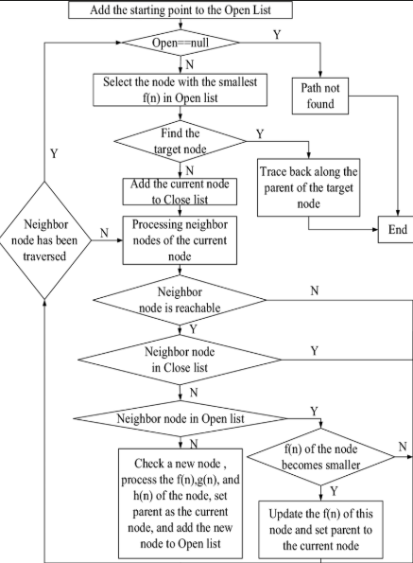
Output:
Shortest Path:
A → C → F → G

Total Cost = 6
Result:
Thus, the A* algorithm was implemented successfully, and the shortest path from the source node to the goal node was obtained.

